**10-11-2021**

First create the folder as

**Product Management System**

Then create two folder

Backend and frontend

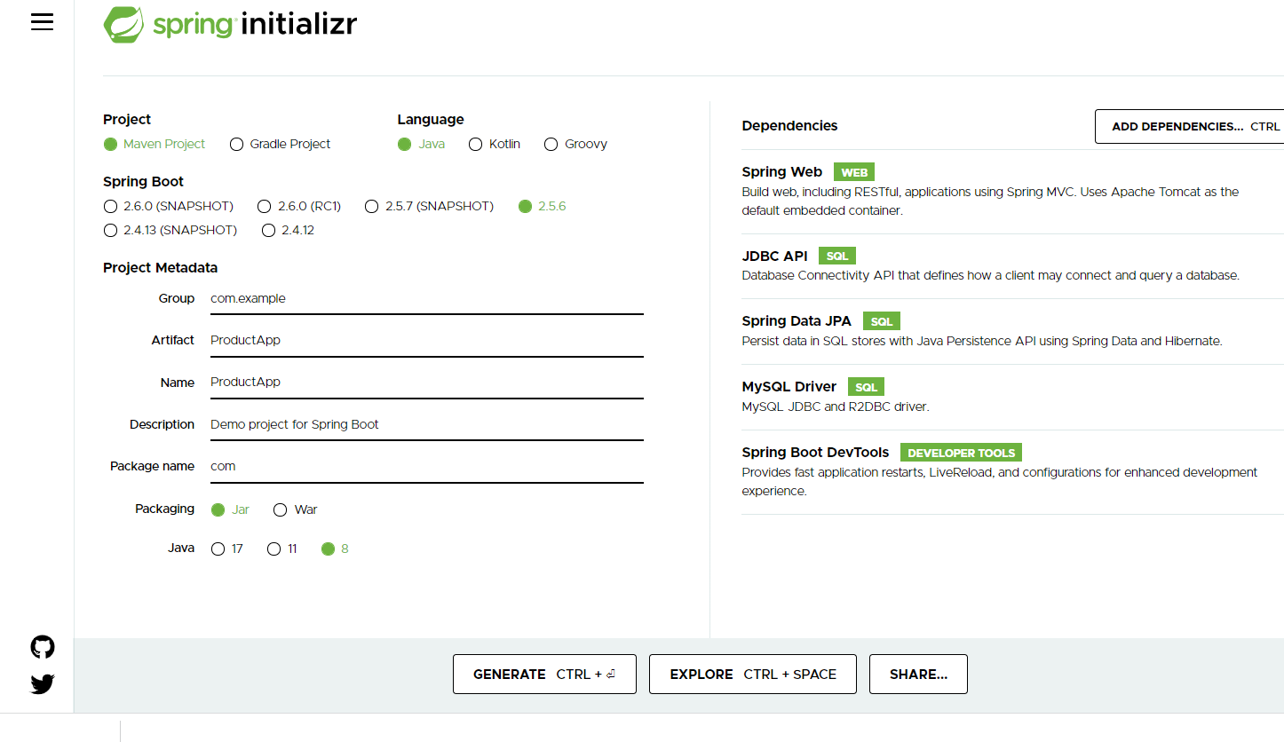

After created backend using Spring boot with Reset and Spring data

Write set of REST API methods.

Then create the Angular project

ng new angular-product-app

routing 🡪 yes

styling 🡪 CSS

ng g c product component

ng g s product service

ng g class product model class

Insert operation

Using Template driven form

We are running two application or domain

Front end running on port number 4200

Backend running on port number 9090

CORS : Cross Origin Resource Sharing

By default HttpClient get, post, put and delete method return type is JSON consider ie Response.